TASK 5
EXAMINE SYSTEM CALLS

Program 1
Aim: To show one system call from each category: process control, file management, device management, information maintenance, communication and protection.
Program
/categories.c - one system call from each category
#define _GNU_SOURCE
#include <stdio.h>
#include <stdlib.h>
#include <fcntl.h>
#include <unistd.h>
#include <string.h>
#include <sys/wait.h>
#include <sys/stat.h>
#include <sys/ioctl.h>
#include <time.h>

int main(void)
{
char buf[64];
/* 1. PROCESS CONTROL */
pid_t pid = fork();
if (pid == 0) { execlp("true", "true", (char *)NULL); _exit(1); }
waitpid(pid, NULL, 0);
/* 2. FILE MANAGEMENT */
int fd = open("demo.txt", O_CREAT | O_WRONLY | O_TRUNC, 0644);
write(fd, "hello OS\n", 9);
close(fd);
/* 3. DEVICE MANAGEMENT (device file + ioctl) */
int tty = open("/dev/null", O_WRONLY);
ioctl(tty, 0x5401 /*TCGETS*/, buf); /* fails on /dev/null: shows the call */
close(tty);
/* 4. INFORMATION MAINTENANCE */
getpid(); time(NULL); gethostname(buf, sizeof buf);
/* 5. COMMUNICATION */
int p[2]; pipe(p);
write(p[1], "ping", 4); read(p[0], buf, 4);
close(p[0]); close(p[1]);
/* 6. PROTECTION */
chmod("demo.txt", 0600); umask(022);
return 0;
}
Output
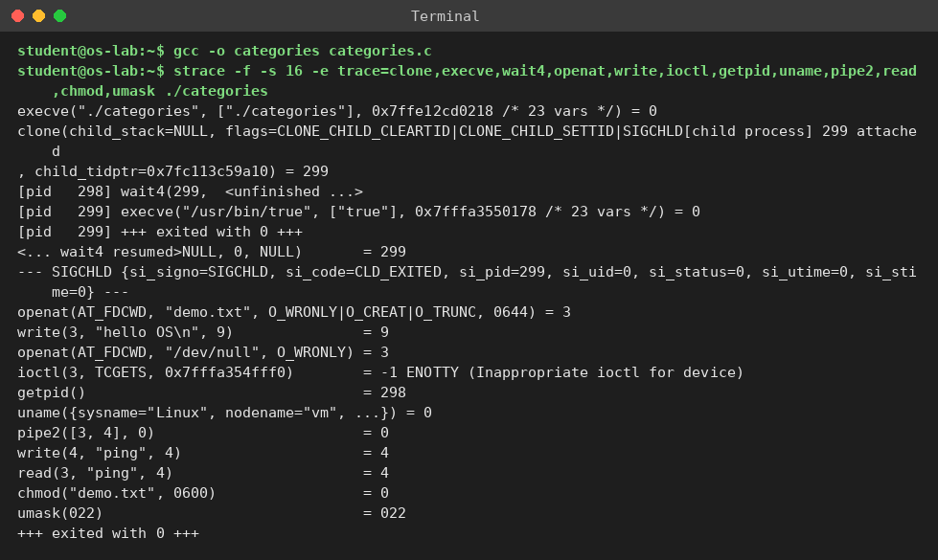
Result: all six categories were seen as real kernel calls. fork() appeared as clone, and time() made no system call (it is served from user space).
Program 2: sys_read.c, following one read()

Program 2
Aim: To follow a read() system call using strace and to view the library wrapper (syscall trap) in the disassembly.
Program
/* sys_read.c - copy a file using the raw system calls open/read/write/close */
#include <stdio.h>
#include <stdlib.h>
#include <fcntl.h>
#include <unistd.h>

int main(int argc, char *argv[])
{
if (argc != 3) { fprintf(stderr, "usage: %s <file> <bufsize>\n", argv[0]); return 1; }
size_t b = (size_t)atol(argv[2]);
char *buf = malloc(b);
int fd = open(argv[1], O_RDONLY);
if (fd < 0) { perror("open"); return 1; }
ssize_t n; long total = 0;
while ((n = read(fd, buf, b)) > 0) { /* system call: read */
total += n;
}
close(fd);
fprintf(stderr, "bytes read = %ld\n", total);
free(buf);
return 0;
Output
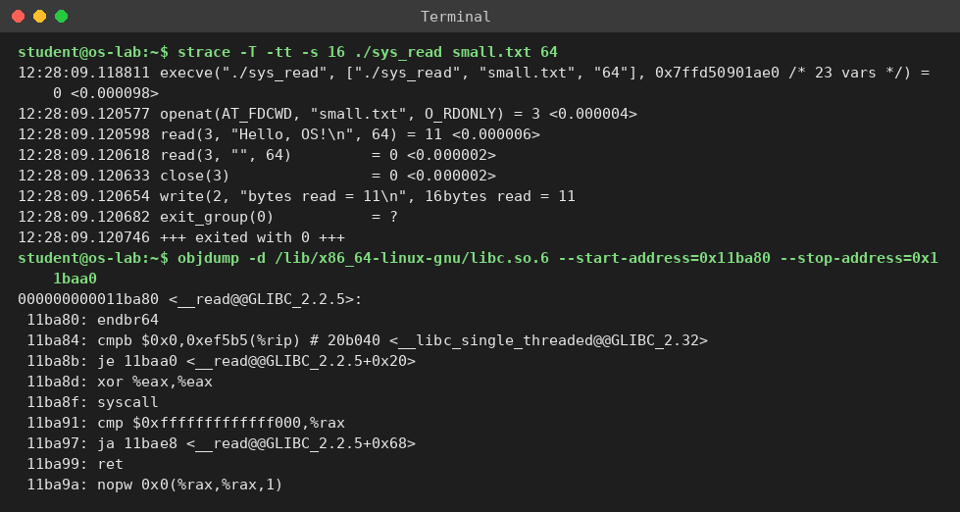
Result: the call goes library wrapper, then syscall trap, then kernel copy (11 bytes), then return. The second read returns 0, which means end of file.

Program 3
Aim: To pass system-call parameters in registers (rax, rdi, rsi, rdx) without the C library.
Program
/* raw_regs.c - invoke write() with NO libc wrapper: parameters in registers */
int main(void)
{
const char msg[] = "Hello from raw syscall\n";
long ret;
/* x86-64 Linux: rax=syscall no (1=write), rdi=fd, rsi=buf, rdx=count */
__asm__ volatile (
"syscall"
: "=a"(ret)
: "a"(1L), "D"(1L), "S"(msg), "d"(sizeof msg - 1)
: "rcx", "r11", "memory");
return (int)(ret > 0 ? 0 : 1);
}
Output
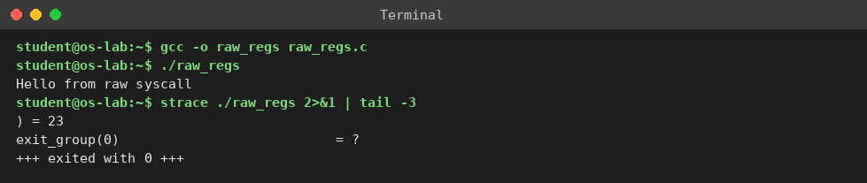
Result: the message was printed with no library call. Only the registers were used: rax=1 (write), rdi=1, rsi=message address, rdx=23.

Program 4
Aim: To count read() system calls for a file of n = 40960 bytes: raw read() with buffer b (about n/b) versus fread() with library buffering (about n/4096).
Program
/* lib_read.c - same job using the C library fopen/fread/fclose */
#include <stdio.h>
#include <stdlib.h>

int main(int argc, char *argv[])
{
if (argc != 3) { fprintf(stderr, "usage: %s <file> <bufsize>\n", argv[0]); return 1; }
size_t b = (size_t)atol(argv[2]);
char *buf = malloc(b);
FILE *fp = fopen(argv[1], "r");
if (!fp) { perror("fopen"); return 1; }
size_t n; long total = 0;
while ((n = fread(buf, 1, b, fp)) > 0) /* library call: may or may not trap */
total += n;
fclose(fp);
fprintf(stderr, "bytes read = %ld\n", total);
free(buf);
return 0;
}
Output
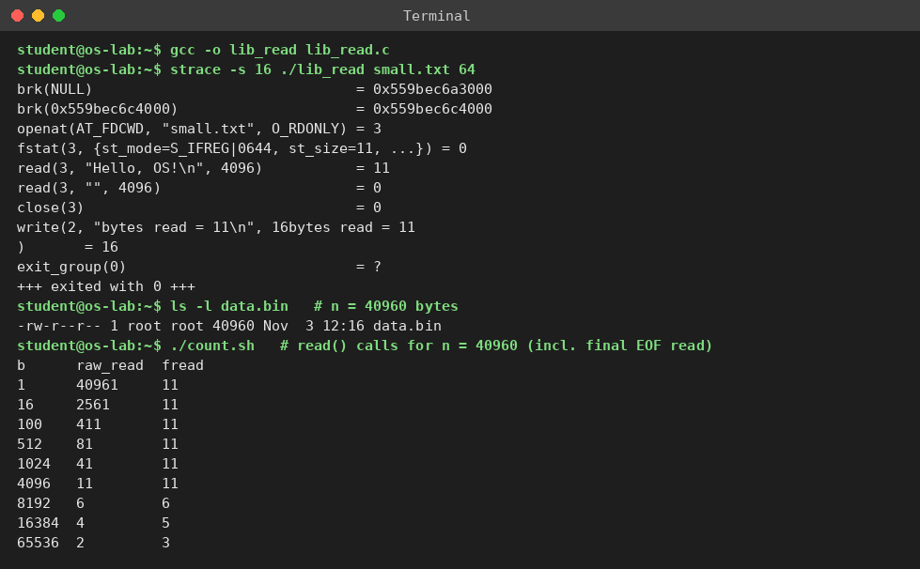
Result: raw calls follow n/b + 1 and library calls follow n/4096 + 1 (11 here). The extra buffer space is 4096 bytes plus a 216-byte FILE structure, about 4.3 KB per open file.

Program 5
Aim: To compare 40,960 one-byte write() calls with fwrite() and measure the time for 4,000,000 bytes.
Program
#include <stdio.h>
#include <stdlib.h>
#include <fcntl.h>
#include <unistd.h>
int main(int argc,char**argv){
long n=40960; char c='A';
if(argv[1][0]=='s'){ int fd=open("out_sys.txt",O_CREAT|O_WRONLY|O_TRUNC,0644);
for(long i=0;i<n;i++) write(fd,&c,1); close(fd);}
else { FILE*f=fopen("out_lib.txt","w");
for(long i=0;i<n;i++) fwrite(&c,1,1,f); fclose(f);}
return 0; }
Output
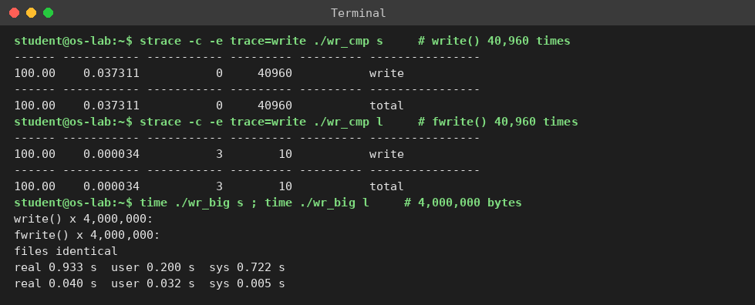
Result: the library cut the calls by about 4096 times and ran about 23 times faster, and the output file was the same.

